COUNCIL ASSESSMENT REPORT

|  |  |  |
| --- | --- | --- |
| **Panel Reference** | **PPSHCC-49** | |
| **DA Number** | **DA 2020-567** | |
| **LGA** | **Maitland** | |
| **Proposed Development** | **Residential aged care facility (168 beds, demolition of existing facility, tree removal, car parking, signage and associated site works)** | |
| **Street Address** | **7 Martin Close & 42 Stronach Avenue, East Maitland** | |
| **Applicant/Owner** | **Churches of Christ Community Care** | |
| **Date of DA lodgement** | 19 June 2020 | |
| **Total number of Submissions**  **Number of Unique Objections** | * Four (4) * Three (3) | |
| **Recommendation** | **Approval** | |
| **Regional Development Criteria (Schedule 7 of the SEPP (State and Regional Development) 2011** | **Schedule 7 – Part 2 General Development over $30 million.**  The estimated capital investment value is $36,737,968. | |
| **List of all relevant s4.15(1)(a) matters** | * State Environmental Planning Policy 55 – Remediation of Land * State Environmental Planning Policy 64 – Advertising and Signage * State Environmental Planning Policy (Housing for Seniors or People with a Disability) 2004 * State Environmental Planning Policy (Infrastructure) 2007 * State Environmental Planning Policy (State and Regional Development) 2011 * State Environmental Planning Policy (Koala Habitat Protection) 2019 * Maitland Local Environmental Plan 2011 * Maitland Development Control Plan 2011 | |
| **List all documents submitted with this report for the Panel’s consideration** | * Appendix A – Draft Schedule of Conditions * Appendix B – Development Plans * Appendix C – General Terms of Approval * Appendix D – Ausgrid Comments * Appendix E – Submissions | |
| **Clause 4.6 requests** | Not applicable | |
| **Summary of key submissions** | Appropriate reuse of materials from the demolition, privacy/overlooking, noise, lighting impacts, excessive bulk and scale, adequacy of the documentation lodged with the application and public interest. | |
| **Report prepared by** | **Kristy Cousins – Senior Development Planner Maitland City Council** | |
| **Report reviewed by** | **Cindy Littlewood, Manager Development & Compliance** | |
| **Report date** | 16 November 2020 | |
| **Summary of s4.15 matters**  Have all recommendations in relation to relevant s4.15 matters been summarised in the Executive Summary of the assessment report? | | **Yes** | |
| **Legislative clauses requiring consent authority satisfaction**  Have relevant clauses in all applicable environmental planning instruments where the consent authority must be satisfied about a particular matter been listed, and relevant recommendations summarized, in the Executive Summary of the assessment report?  *e.g. Clause 7 of SEPP 55 - Remediation of Land, Clause 4.6(4) of the relevant LEP* | | **Yes** | |
| **Clause 4.6 Exceptions to development standards**  If a written request for a contravention to a development standard (clause 4.6 of the LEP) has been received, has it been attached to the assessment report? | | **Not applicable** | |
| **Special Infrastructure Contributions**  Does the DA require Special Infrastructure Contributions conditions (S7.24)?  *Note: Certain DAs in the Western Sydney Growth Areas Special Contributions Area may require specific Special Infrastructure Contributions (SIC) conditions* | | **No** | |
| **Conditions**  Have draft conditions been provided to the applicant for comment?  *Note: in order to reduce delays in determinations, the Panel prefer that draft conditions, notwithstanding Council’s recommendation, be provided to the applicant to enable any comments to be considered as part of the assessment report* | | **Yes** | |

**INTRODUCTION**

**EXECUTIVE SUMMARY**

Development consent is sought for the demolition of existing Residential Aged Care Facility (RACF) and construction of a new 168 bed RACF and associated infrastructure. The Development Application (DA) 2020/567 was lodged on the 19 June 2020 with a Capital Investment Value of works estimated at $36,737,968 plus GST. The DA is required to be reported to the Hunter Central Coast Regional Planning Panel (HCCRPP) for determination on the basis that the estimated value of the development exceeds the $30 million threshold for private development.

The legal description of the land on which the development is to be carried out is Lot 57 DP 260833 & Lot 5 DP 258655, known as 7 Martin Close & 42 Stronach Avenue, East Maitland. Lot 57 is an irregular shaped allotment around 1.33 hectares in area. The lot currently comprises the existing residential aged care facility (RACF) and gains access via Martin Close. Lot 5 is a rectangular shaped allotment around 669.3m2 in area and it is currently vacant.

The development proposal is integrated development pursuant to Section 4.46 of the Environmental Planning & Assessment Act 1979 (EP&A Act) as an approval is required under the Rural Fires Act 1997 and the Water Management Act 2000. In accordance with 100B of the Rural Fires Act 1997 the proposed development is a special fire protection purpose. The NSW Rural Fire Service (RFS) has issued General Terms of Approval (GTA’s), subject to conditions. In accordance with 91 of the Water Management Act 2000 the development requires a Controlled Activity Approval (CAA). The Natural Resource Access Regulator (NRAR) has issued GTA’s subject to conditions.

The application was notified for a period of 30 days between 3 July 2020 and 3 August 2020 and Four (4) submissions were received. The issues raised within the submissions include appropriate reuse of materials from the demolition, privacy/overlooking, noise, lighting impacts, and adequacy of the documentation lodged with the application, excessive bulk and scale and public interest. These issues are addressed in the assessment report and are not considered significant enough to warrant refusal of the application.

The application has been assessed against the relevant heads of consideration under section 4.55 of the EP&A Act and found to be satisfactory subject to the recommended conditions of consent. A summary of key considerations includes:

**SEPP 55 – Remediation of Land (Clause 7)**. A stage 1 preliminary assessment identified potential for contamination on the site, therefore a stage 2 detailed site investigation was undertaken. Based on the findings of the assessment the site is considered suitable for the proposed development with no further investigation or remediation required.

**SEPP 64 – Advertising and Signage (Schedule 1 – Assessment Criteria).** The proposed signage is compatible with the surrounding character and desired amenity of the area whilst being of high quality design and finish.

**SEPP (Housing for Seniors or People with a Disability) 2004 (Clause 18, 26, 27, 28, 30, 32 & 48).** The development complies with the relevant site-related, design requirements and development standards identified within the SEPP.

**SEPP (Infrastructure) 2007 (Clause 45).** The application was referred to Ausgrid in accordance with Clause 45 of the SEPP. Ausgrid advised that they consent to the development subject to conditions.

In accordance with Clause 104 and Schedule 3 the proposal is not located within 90m of a classified road, and the development does not trigger the traffic generating provisions, therefore referral to Transport for NSW is not required under the SEPP.

**SEPP (State and Regional Development) 2011 (Clause 20)**. The development is considered to be regionally significant, accordingly the application is submitted to the HCCRPP for determination.

**SEPP (Koala Habitat Protection) 2019 (Clause 10).** The SEPP applies to the site, whilst the site does comprise high quality Koala habitat, it does not constitute core Koala habitat. Preparation of a Koala plan of management is not required and the proposal satisfies the provisions of the SEPP.

**Maitland LEP 2011.** The subject land is zoned R1 General Residential under the Maitland LEP 2011. The proposed development is defined as a Residential Care Facility which is a type of Seniors Housing permissible with consent in the R1 zone. The proposal is considered consistent with the objective of the zone.

In summary the assessment of the proposed development has adequately addressed all considerations required by the relevant environmental planning instruments. The application is therefore presented to the HCCRPP with a recommendation for approval.

**OFFICERS RECOMMENDATION**

**That the Hunter Central Coast Regional Planning Panel approve Development Application 2020-567 for a Residential Aged Care Facility (168 beds, demolition of existing facility, tree removal, car parking, signage and associated site works) on Lot 57 DP 260833, 7 Martin Close and Lot 5 DP 258655, 42 Stronach Avenue, East Maitland subject to the recommended conditions of consent set out in Appendix A.**

**INTRODUCTION**

Development consent is sought for the demolition of existing Residential Aged Care Facility (RACF) and construction of a new RACF and associated infrastructure. The Development Application (DA) 2020/567 was lodged on the 19 June 2020 with a Capital Investment Value of works estimated at $36,737,968 plus GST. The DA is required to be reported to the HCCRPP for determination on the basis that the estimated value of the development exceeds the $30 million threshold.

**SITE DESCRIPTION**

The legal description of the land on which the development is to be carried out is Lot 57 DP 260833, known as 7 Martin Close and Lot 5 DP 258655, known as 42 Stronach Avenue, East Maitland. Lot 57 is an irregular shaped allotment around 1.33 hectares in area which currently comprises the existing residential aged care facility (RACF) and gains access via Martin Close. Lot 5 is a rectangular shaped allotment around 669.3m2 in area and is currently vacant land.

The existing development on lot 57 comprises a 60 bed RACF originally built in 1984 which includes a large off street car park, landscaping and separate entrance/egress via Martin Close. There is an existing pedestrian access bridge over Two Mile Creek that links the site with the Fresh Hope Retirement Village to the north. The subject site is located approximately 250m from the Green Hills Shopping Centre.

The subject site falls around 6m from south to north towards Two Mile Creek which is a vegetation riparian corridor maintained by Maitland City Council. An aerial photo from 2019 of the subject site is provided in figure 1.

***Figure 1 – Locality Plan***

**PROPOSAL**

The development application seeks consent for a residential aged care facility (RACF) which includes the following:

* Demolition the existing residential aged care facility and current at grade car park;
* Site preparation works including excavation works for the lower ground level;
* Construction and use of a new 2-4 storey residential care facility that includes lower ground parking for 24 cars, 11,377.11m2 of GFA comprising 160 beds, 8 respite beds, a family room, back of house areas, administration /offices, health and wellbeing areas, communal kitchen, dining and lounge areas, training areas, recreation areas, a community kitchen and ancillary café;
* A new entrance driveway and drop off zone from Martin Close and provision of 7 parking spaces;
* A secondary on-grade car park comprising 19 car spaces and loading dock driveway;
* New maintenance service track allowing vehicles to exit via Stronach Ave;
* Two business identification signs;
* Removal of 31 trees; and
* Associated landscaping works, including management of riparian zone.

The concept plans are provided in Figure 2 below. A full set of the development plans can be viewed in Attachment B.

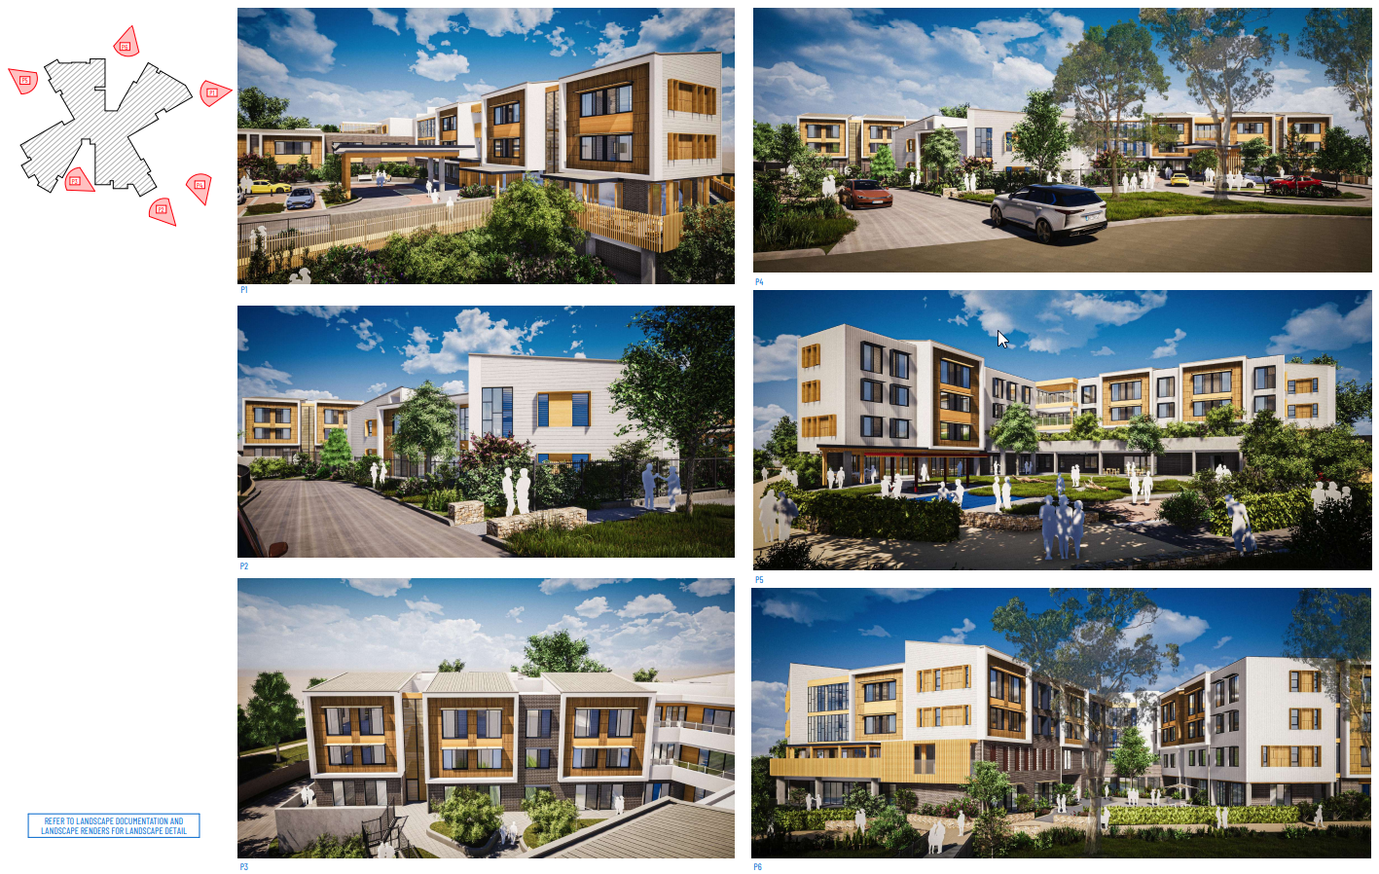

***Figure 2 – Concept Plans***

Specific details of the proposal are as follows:

Residential Aged Care Facility (RACF) Built Form and Facilities

The RACF proposed is a part two and four storey building that has been designed as a four-wing concept connected via a central hub. Each wing will accommodate 16 RAC beds, with the four wings extending out from the central hub to create landscape courtyards between each wing.

The floor levels above the main entry are replicated above one another, with the south eastern wing 2 storeys as it fronts Martin Close. As the building steps down the sloping site towards the north and north west, the building increases to four storeys. The external walls range between 6.8m in the south eastern wing to 14.07m in northern wing.

The development will be constructed using a variety of materials and finishes to create a contemporary built form which provides visual interest. The materials include face brick, concrete, timber look cladding, shade awnings, perforated brick screens and window shutters.

*Lower Ground Level*

The northern wing of the lower ground floor will comprise the wellness area including a community kitchen, multifunctional activity space, allied health consulting rooms, gym, library, consultation / office areas and back of house areas.

The north eastern wing on will comprise an 8 room / 8 bed respite area including lounge room, dining room, family room and activities area. This will primarily operate as a day centre and can accommodate up to 20 people during the day, with the capacity for overnight stays.

The south western wing includes the back of house areas including laundry, kitchen, staff room, waste, storage and staff amenities. This level will also include the lower ground car park for 24 cars with entrance via the new vehicular access road off Martin Close. The access road is extended to include a loading dock adjacent the back of house area of this level.

*Ground Level*

The northern wing comprise the entry lobby / reception area, administration and communal resident / visitor section. The wing provides a café for residents, visitors and staff, with a multi purpose room and function room located adjacent the café. This wing also provides for a chaplain and reflection space leading to an outside space.

The remaining three wings comprise the 16 bed care households situated around the lounge and activity spaces. Each wing includes a kitchen, servery and dining area.

The proposal includes two access points off Martin Close, with the eastern main access point creating a circular driveway arrangement with an at grade car park adjacent the buildings entrance lobby, providing 7 car spaces including 2 accessible spaces. This provides for a drop off zone including undercover ambulance bay adjacent the entrance lobby and space for 10 bicycle spaces. The western access point provides access to the lower level car park, as well as the at grade car park providing 19 car spaces adjacent the western boundary. The western access driveway will continue around the perimeter of the site to an exit point off Stronach Avenue to be used by emergency service and maintenance vehicles.

*Level 1*

Level 1 will comprise four x 16 bed care households situated around the lounge and activity spaces. Each wing includes a kitchen, servery and dining area, with a space in the centre for staff and nurses. Three balcony spaces have been provided on the southern side of the building.

*Level 2*

Level 2 will comprise three x 16 bed care households situated around the lounge and activity spaces. Each wing includes a kitchen, servery and dining area, with space in the central hub for staff and nurses. The south eastern wing will comprise a community room and outdoor terrace area.

*Pedestrian Access*

Pedestrian access to the site is provided off Martin Close, with a new internal paved footpath to circulate the site. This will connect to the existing pedestrian bridge link the site with the adjacent Fresh Hope Retirement Village. It is proposed to extend the public footpath on the south western side of Stronach Avenue approximately 55m to the frontage of 42 Stronach Avenue.

*Landscaping*

The landscaping has been designed to retain existing trees where possible, while providing appropriate paths of travel and clear delineation through pedestrian and vehicular entry point. The development incorporates landscaping over 62% of the site, with 28% of the total site a deep soil zone.

The landscaping will include:

* Grassed lawn areas around the site;
* Entry forecourt plaza includes planter beds, permeable paving to maximise tree plantings;
* Native meadow adjacent the entry forecourt. This area include remnant trees with an accessible boardwalk the connects the entry forecourt to the maintenance track adjacent the riparian corridor. This includes seating at each landing to provide residents and visitors the opportunity to rest;
* Dementia courtyard is a secure and screened area for residents that provides easy access from internal spaces. The courtyard includes raised planters provide for greenery as well as ample seating spaces and a walking circuit for residents;
* Circuit path provides an accessible paved walkway at a 1 in 20 grade with landings connecting the path across the site to create an external circuit for residents and visitors;
* The “Backyard” is located in the south western corner of the property and provides a multi use area for activities. This areas includes a shed, orchards, vegetable gardens and chicken/avery coop for residents. A barbecue facility with shelter and playground provide a space for social gatherings. As this area is located within the required Asset Protection Zone it will be planted with selective fire retardant species;
* Sensory garden adjacent the wellness centre and day respite wing at the lower ground floor. This area includes gardens and artificial turf to create an outdoor space which provides opportunities for outdoor exercise sessions;
* Maintenance access track to be constructed 4m wide with stabilised gravel whilst primarily for emergency access and maintenance vehicles, also provides an accessible circuit path for residents; and
* Upper ground floor terrace area with raised planter beds provide a green outlook from the adjoining rooms provides an undercover walkway from the loading dock to the lower ground floor.

*Tree Removal*

The arboricultural impact assessment report identifies 103 trees on the site, with 31 trees located within the building footprint that require removal. An additional 7 trees were recognised as having some minor and acceptable encroachments and 2 have major encroachments as defined under AS4970. The report identifies that the 2 trees with major encroachments may be successfully retained with minimal impacts to their longer term health or stability.

The development has retained all trees that were identified as high retention value trees, specifically those reflective of the Lower Hunter Spotted Gum-Ironbark Forest EEC.

*Signage*

It is proposed to locate two identical business identification signs, one at each of the vehicular entrances off Martin Close (an identical sign adjacent the maintenance access onto Stronach Avenue has been removed from the application). The sign which is 2000h x 440w is to be affixed to a rendered and painted blockwork wall constructed on a 600 high natural stone cladding with ground mounted LED up lighting.

**PLANNING ASSESSMENT**

**Section 4.15(1)(a)(i) Any relevant environmental planning instrument**

***Environmental Planning & Assessment Act 1979 (EP&A Act)***

The development proposal is integrated development pursuant to Section 4.46 of the EP&A Act as an approval is required under the *Rural Fires Act 1997* and the *Water Management Act 2000.*

In accordance with 100B of the *Rural Fires Act* 1997 the proposed development is a special fire protection purpose. The NSW Rural Fire Service (RFS) has issued GTA’s, subject to conditions. The conditions require:

* The area identified within the *Fresh Hope Care Bushfire Fuel Management Plan Proposal* to be maintained as an Inner Protection Area in accordance with the requirements of Planning for Bush Fire Protection 2019;
* Construction to comply with section 3 and 5 (BAL 12.5) requirements;
* The access roads to comply with general requirements of Table 6.8b of Planning for Bush Fire Protection 2019;
* The provision of water, electricity and gas to comply with Table 6.8c of Planning for Bush Fire Protection 2019;
* Landscaping to comply with the RFS requirements; and
* A Bush Fire Emergency Management and Evacuation Plan to be prepared in accordance with the RFS and Australian Standards. It is to include planning for early relocation of occupants. This plan should be provided to the local Emergency Committee for its information prior to occupation of the development.

These are included as an attachment to the draft conditions of consent.

In accordance with 91 of the *Water Management Act* 2000 the development requires a Controlled Activity Approval (CAA). The Natural Resource Access Regulator (NRAR) has issued GTA’s subject to conditions. The conditions require:

* Obtain a CAA prior to the commencement of works on waterfront land;
* Erosion and sediment controls; and
* Submissions of relevant plans and documentation.

These are included as an attachment to the draft conditions of consent.

A copy of the Agency correspondence is provided in Attachment C.

***State Environmental Planning Policies***

**State Environmental Planning Policy 55 – Remediation of Land**

State Environmental Planning Policy No. 55 – Remediation of Land requires a consent authority to consider if land is contaminated and if so, whether after remediation the site will be suitable for its intended use.

A stage 1 preliminary site investigation prepared by JK Environments was lodged with the application in support of the proposal. The site information indicates that between 1921 and 1976 the land was potentially used for farming / agricultural purposes or was disused vacant land. Between 1984 and 1993 the site was developed for the existing use as a residential aged care facility. Fill material was identified in numerous locations around the site. Given the age of the building the report identifies that there is the potential for hazardous building materials to be present. A stage 2 detailed site investigation was recommended to characterise the site contamination conditions.

JK Environments prepared a Stage 2 detailed site investigation report. Soil samples were obtained from 24 locations across the site between the 24th – 26th February 2020 and groundwater samples were obtained from two monitoring wells on the 2nd March 2020.

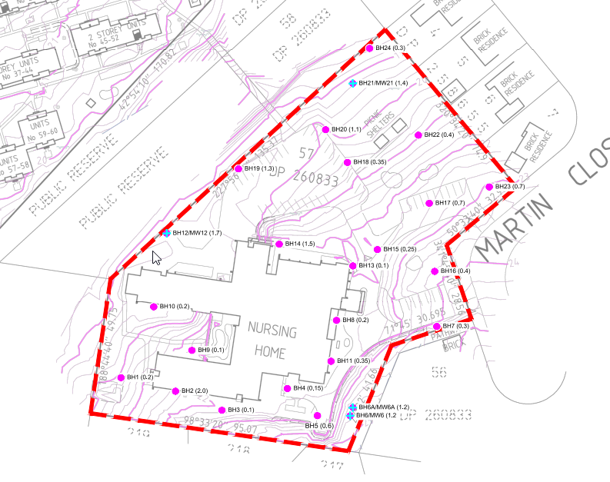

***Figure 3 – Sample location plan***

The report identifies that the elevated concentrations of the contaminant of potential concern (CoPC) encountered were not above the adopted Site Assessment Criteria (SAC) in any of the soil samples analysed. On this basis there has been no confirmed source of contamination and no complete source linkage. No asbestos containing materials were encountered in the fill material on the site. It was determined that it was unlikely that significant and widespread asbestos will be encountered, and any residual risk can be managed via an unexpected finds protocol.

Cadmium, nickel and zinc were encountered in groundwater above the ecological SAC. The source of these heavy metals was identified as most likely to be associated with regional factors and were not considered to pose a risk. The management of groundwater will be required during construction / excavation in regard to dewatering.

Based on the findings of the assessment, the site is considered suitable for the proposed development with no further investigation or remediation required. It is recommended that the development be undertaken in accordance with the unexpected finds protocol during construction. The report also recommends that a hazardous building materials assessment should be undertaken of all buildings and structures prior to demolition to reduce any associated risk of contaminating the site during demolition.

The development is considered satisfactory under the provisions of SEPP 55 subject to the recommended conditions of consent.

**State Environmental Planning Policy 64 – Advertising and Signage**

This State Environmental Planning Policy aims to ensure that advertising and signage not only provides effective communication but is also compatible with the visual character and desired amenity of the area whilst being of a high-quality design and finish.

The signage proposed under the application is defined as business identification signage.

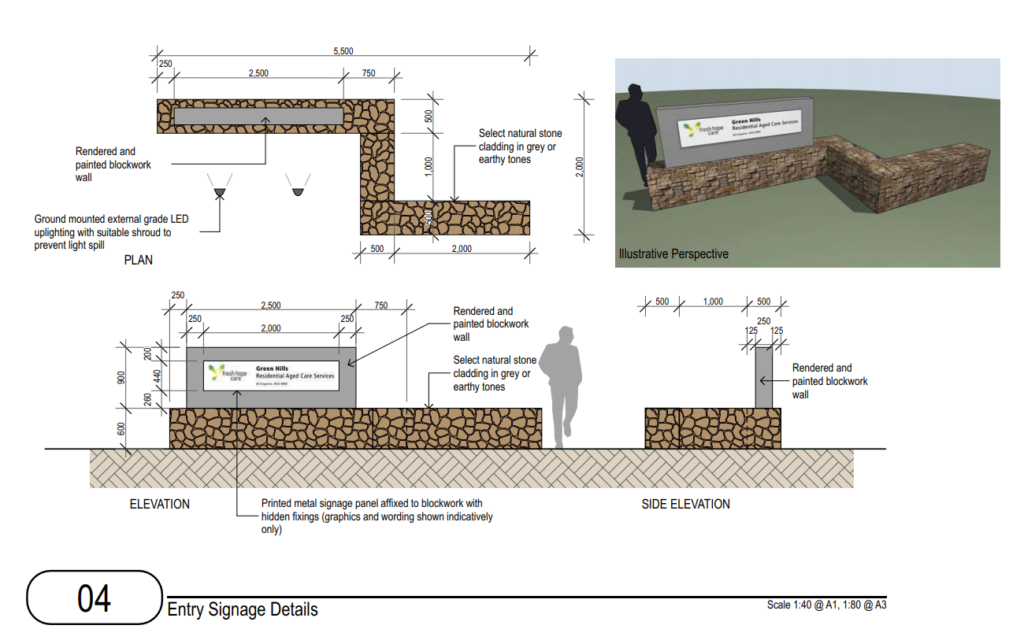

***Figure 4 – Proposed Signage Details***

It is proposed to locate two of the above business identification signs for the development at each of the vehicular entrances off Martin Close. The identification sign which is 2000h x 440w is to be affixed to a rendered and painted blockwork wall constructed on a 600 high natural stone cladding with ground mounted LED up lighting.

Clause 8 of the SEPP requires the consent authority to be satisfied that the signage is consistent with the objectives of the SEPP as set out in clause 3(1)(a) and satisfies the assessment criteria specified in Schedule 1.

The proposed signage has been assessed in accordance with the criteria specified by Schedule 1 as follows:

**1**   **Character of the area**

*Is the proposal compatible with the existing or desired future character of the area or locality in which it is proposed to be located?*

*Is the proposal consistent with a particular theme for outdoor advertising in the area or locality?*

The signs are modest in height and materials which are appropriate for the subject site. They provide a clear identification of the intended use of the site in a form compatible with the surrounding residential streetscape and locality.

**2**   **Special areas**

*Does the proposal detract from the amenity or visual quality of any environmentally sensitive areas, heritage areas, natural or other conservation areas, open space areas, waterways, rural landscapes or residential areas?*

The signage is not located near any environmentally sensitive areas, heritage areas or conservation areas. The signs are modest in size, with a maximum height of 1500mm above ground level. This is compatible with the surrounding residential area and will not detract from the visual amenity of the locality.

**3**   **Views and vistas**

*Does the proposal obscure or compromise important views?*

*Does the proposal dominate the skyline and reduce the quality of vistas?*

*Does the proposal respect the viewing rights of other advertisers?*

The signage does not compromise or obscure any vistas or intrude into view corridors currently enjoyed by adjoining residents or the passing public.

**4**   **Streetscape, setting or landscape**

*Is the scale, proportion and form of the proposal appropriate for the streetscape, setting or landscape?*

*Does the proposal contribute to the visual interest of the streetscape, setting or landscape?*

*Does the proposal reduce clutter by rationalising and simplifying existing advertising?*

*Does the proposal screen unsightliness?*

*Does the proposal protrude above buildings, structures or tree canopies in the area or locality?*

*Does the proposal require ongoing vegetation management?*

The signage is of an appropriate height, scale and proportion and will not impact on the streetscape or currently landscape. There is an existing modest sign located adjacent the entrance into the existing facility off Martin Close which will be replaced in a similar location with the proposed signage.

The signage does not screen unsightliness, nor does it protrude above buildings, structures or tree canopies in the area.

**5**   **Site and building**

*Is the proposal compatible with the scale, proportion and other characteristics of the site or building, or both, on which the proposed signage is to be located?*

*Does the proposal respect important features of the site or building, or both?*

*Does the proposal show innovation and imagination in its relationship to the site or building, or both?*

The scale and form of the signage is modest and acceptable in this location. The contemporary design will integrate with the contemporary development proposed RACF. The signs are only located at the entrance point to provide clear and effective identification of the proposed development.

**6**   **Associated devices and logos with advertisements and advertising structures**

*Have any safety devices, platforms, lighting devices or logos been designed as an integral part of the signage or structure on which it is to be displayed?*

Details of the signage is included in the plans including integrated lighting.

**7**   **Illumination**

*Would illumination result in unacceptable glare?*

*Would illumination affect safety for pedestrians, vehicles or aircraft?*

*Would illumination detract from the amenity of any residence or other form of accommodation?*

*Can the intensity of the illumination be adjusted, if necessary?*

*Is the illumination subject to a curfew?*

It is proposed to install ground mounted external grade LEP up-lighting with suitable shroud to prevent light spill. The lights will be directed away from the adjoining residences in Martin Close and will not impact on the amenity of the area.

**8**   **Safety**

*Would the proposal reduce the safety for any public road?*

*Would the proposal reduce the safety for pedestrians or bicyclists?*

*Would the proposal reduce the safety for pedestrians, particularly children, by obscuring sightlines from public areas?*

The proposed signage will not reduce safety for any public road, pedestrian or cyclist. The signage does not obscure sightlines from public or open space areas.

The signage applied for as part of this application has been assessed against the matters for consideration of the SEPP and is found to be compatible with the desired amenity and satisfies the requirements of this SEPP.

**State Environmental Planning Policy (Housing for Seniors or People with a Disability) 2004**

The State Environmental Planning Policy (Housing for Senior or People with a Disability) aims to encourage the provision of housing (including residential care facilities) that will increase the supply and diversity of residences that meet the needs of seniors or people with a disability, make efficient use of existing infrastructure and services and provide for good design.

The proposed development falls under the definition of residential care facility for the purposes of the SEPP, that is: *‘is residential accommodation for seniors or people with a disability that includes— (a) meals and cleaning services, and (b) personal care or nursing care, or both, and (c) appropriate staffing, furniture, furnishings and equipment for the provision of that accommodation and care, not being a dwelling, hostel, hospital or psychiatric facility. Note.  The*[*Aged Care Act 1997*](http://www.legislation.gov.au/)*of the Commonwealth requires residential care facilities to which that Act applies to meet certain requirements*.’

An assessment has been undertaken against the specific requirements of this SEPP is provided below:

| Requirement | Compliance |
| --- | --- |
| Clause 4 – Land to which the Policy applies | |
|  | The subject site is zoned R1 General Residential under the Maitland LEP 2011, under which dwelling houses, residential flat buildings, hospitals etc are permissible with consent.  This SEPP therefore applies. |
| Clause 11 – Residential Care Facilities | |
|  | The proposal is consistent with this Clause of the SEPP. The development will provide integrated health care to residential with the provision of health and wellbeing programs. |
| Clause 18 – Restrictions on occupation of seniors housing allowed under this Chapter | |
|  | Relevant conditions of consent are recommended to ensure that the requirements under this clause are satisfied. |
| Clause 26 – Location and access to Facilities | |
| Residents will have access to shops, banks, retail/commercial services, community services, recreational facilities and the practice of a GP.  Access complies with this clause if there is a transport service available to residents via a suitable access path not more than 400m from the site which will take residents to not more than 400m from the above services which is available during daylight hours, Monday to Friday.  For the purposes of the clause, the overall average gradient along a pathway from the site of the proposed development to the public transport services (and from the transport services to the facilities and services) is to be no more than 1:14, although the following gradients along the pathway are also acceptable:   1. a gradient of no more than 1:12 for slopes for a maximum of 15 metres at a time, 2. a gradient of no more than 1:10 for a maximum length of 5 metres at a time, 3. a gradient of no more than 1:8 for distances of no more than 1.5 metres at a time. | The site is within close proximity to the Stockland Greenhills Shopping centre which provides a range of retail and commercial services. There are numerous banks and a medical centre located within the centre. Whilst the centre is only 200m away from the subject site, the distance to travel from the entrance of the proposed RACF to the pedestrian entrance of the shopping centre is approximately 500m.  As the Subject Site is located outside of Greater Sydney and is more than 400m from the required services the development complies with clause 2(c) by utilising the local bus services. The bus stop picking up from Stronach Avenue is approximately 230m from the proposed RACF. The Access review prepared by Morris Goding Access Consulting demonstrates that the pedestrian footpath to the bus stop to utilise both inbound and outbound bus routes are suitable and comply with the SEPP requirements.  Given the nature of the facilities residents may not always wish to leave the site to seek relevant services. In this regard, the RACF will provide for a café, hair salon, allied health services, provision of meals and cleaning services.  Internal footpaths have been designed in accordance with the SEPP gradient requirements and the Applicant has submitted an Access Report as part of the development demonstrating it is capable of complying with the SEPP.  The location is considered appropriate in terms of its access to essential services and facilities. |
| Clause 27 – Bush fire prone land | |
| Council must be satisfied that the development complies with the requirements of *Planning for Bush Fire Protection* | The subject site is mapped as bush fire prone land; therefore the applicant has submitted a bushfire assessment which was referred to the NSW Rural Fire Service under Section 100B of the Rural Fires Act 1997. The NSW Rural Fire Service have issued General Terms of Approval.  The development is reliant on the on-going management of the adjoining Council owned riparian corridor to the north. This is discussed further within this report. |
| Clause 28 – Water and Sewer | |
| Council must be satisfied that the housing will be connected to a reticulated water system and have adequate facilities | The subject site is currently serviced by reticulated water and sewerage services. The Hunter Water stamped plans confirm that water and sewer are available for connection and that a Section 50 Certificate application has been submitted for assessment.  Hunter Water have also provided a Notice of Formal Requirements for the proposed development. Given the nature of the development, connections will be required to be to the 150 DICL in Martin Close and not via the 80 PVC watermain.    As such the applicant has demonstrated the site can be connected to a reticulated water system and there is adequate capabilities and facilities for the removal or disposal of sewage. |
| Clause 30 – Site Analysis | |
| A consent authority must not grant consent to a DA unless the applicant has taken into account a site analysis prepared by the applicant in accordance with this clause. Site analysis to address site dimensions, topography, services, existing vegetation, microclimates, improvements, views, overshadowing, neighbouring buildings, privacy, levels, street frontage features, built form, character, heritage features, distance to local facilities, public open space, adjoining bushland/ environmentally sensitive land, sources of nuisance. | A site analysis has been provided to Council which informs the design of the proposed development and is considered compliant with the provisions of this clause. |
| Clause 32 – Design of residential development | |
|  | The proposal is considered consistent with the Principles set out in Division 2 as detailed below. |
| Clause 33 - Neighbourhood Amenity and Streetscape | |
| 1. Development recognises the desirable elements of the location’s current character (or, in the case of precincts undergoing a transition, where described in local planning controls, the desired future character) so that new buildings contribute to the quality and identity of the area. | The site is located adjacent the Greenhills Shopping Centre which has recently undergone a major redevelopment. The Greenhills Shopping Centre site has a 24m maximum height identified in the Maitland LEP. Whilst the existing buildings immediately adjacent the development are single storey residential, the proposal is not considered out of character with the area.  The development has been designed with due regard to the riparian corridor and retaining suitable landscape buffers to the surrounding development. The design of the building provides interest whilst reducing the bulk and adequately addresses the topography of the site. |
| 1. Development retain, complement and sensitively harmonise with any heritage conservation areas in the vicinity and any relevant heritage items that are identified in a local environmental plan | The site is not within a Heritage Conservation Area nor listed as an item of heritage significance. There are no heritage conservation areas or heritage items in close proximity to the site. |
| 1. Development maintains reasonable neighbourhood amenity and appropriate residential character by:  * providing building setbacks to reduce bulk, overshadowing; and * using building form and siting that relates to the site’s land form, and * adopting building heights at the street frontage that are compatible in scale with adjacent development, and considering where buildings are located on the boundary, the impact of the boundary walls on neighbours. | The site and immediate surrounding area are primarily that of residential dwellings with the commercial shopping centre located to the north west of the site.  The proposed new RACF is fundamentally different in scale to the free-standing domestic dwellings. The building form is broken up and articulated to reduce the bulk of the building, this allows for a less intrusive design and will aid in the application of solar access.  The application demonstrates that as the building is centrally located on the site there are no issues with overshadowing on the adjoining properties.  The building also provides generous setbacks to allow for internal amenity whilst reducing the impacts on surrounding residents. The proposal involves a 2 to 4 storey building with the upper floors stepped back to reduce the scale as it relates to Martin Street and the adjoining residential houses. The proposal adequately responds to the topography of the site. |
| 1. Development is designed so that the front building of the development is set back in sympathy with, but not necessarily the same as, the existing building line. | The building has been centrally located on the site to minimise impacts. The development is setback 11.5m at the closest point to Martin Close. The 4-wing configuration reduces the perceived bulk and scale of the building in this location. The siting of the building is considered sympathetic with the surrounding context. |
| 1. Development embodies planting that is in sympathy with, but not necessarily the same as, other planting in the streetscape. | The concept landscape plan is considered to provide satisfactory streetscape consistent with the existing character of the site. |
| 1. Development retains, wherever reasonable, major existing trees | The Arboricultural Impact Assessment Report assessed all trees on the subject site and surrounds. In summary of the 103 trees assessed:   * 31 trees are proposed to be removed from the subject site for the development footprint (most of these are small or exotic trees with low retention values, no trees within the riparian corridor to be removed); * 63 are to be retained with no foreseeable impacts from the construction (61%); * 7 have some minor or acceptable encroachments; and * 2 have major encroachments, however in the authors opinion the potential impacts are within acceptable limits and the trees may be successfully retained.   The recommendations include measures for tree protection and the recommended mitigation measures outlined in the Arboricultural Impact Assessment Report have been included in the recommended conditions of consent. |
| 1. Development is designed so that no building is constructed in the riparian zone. | The site is adjacent Two Mile Creek which is identified as a second order riparian corridor. The building is not to be constructed within the 20m riparian buffer from the Creek. Some landscaping and infrastructure works are proposed, for which a Controlled Activity Approval from Natural Resources Access Regulator is required. |
| Clause 34 – Visual and Acoustic Privacy | |
| The proposed development should consider the visual and acoustic privacy of neighbours in the vicinity and residents by appropriate site planning, the location and design of windows and balconies, the use of screening devices and landscaping, ensuring acceptable noise levels in bedrooms of new dwellings by locating them away from driveways, parking areas and paths).  Note.   The Australian and New Zealand Standard entitled AS/NZS 2107–2000*, Acoustics—Recommended design sound levels and reverberation times for building interiors* and the Australian Standard entitled AS 3671—1989*, Acoustics—Road traffic noise intrusion—Building siting and construction*, published by Standards Australia, should be referred to in establishing acceptable noise levels. | The development has been designed to with due consideration of visual privacy within the development and neighbouring properties. Given the separation between the arms of the building, the proposed landscaping and angles of the windows the development achieves adequate visual privacy.    The development has been amended to introduce privacy blades, balcony screens and window tint finishes where the development interfaces with the adjoining properties (44 Stronach Ave, 3-7 Erin Close and 6 Martin Close) to address any potential privacy issues.  An acoustic report prepared by TTM Consulting was submitted with the application which considered noise impacts for mechanical plant noise, vehicle movement noise, noise from community areas and noise form additional generated road traffic. The impact from construction noise and vibration were also assessed.  The report demonstrates that the development can achieve compliance with the noise requirements for traffic, vehicle movements, outdoor community areas without any additional mitigation measures. Whereas the mechanical plant equipment require screening for compliance.  It is noted that there are a small number of bedrooms located in close proximity to the driveway and carpark entry. The application identifies that these will be fitted with visual and acoustic amelioration measures to mitigate any adverse impacts. |
| Clause 35 – Solar Access and Design for Climate | |
| The development should:  Ensure adequate daylight to the main living areas of neighbours in the vicinity and residents and adequate sunlight to substantial areas of private open space, and involve site planning, dwelling design and landscaping that reduces energy use and makes the best practicable use of natural ventilation solar heating and lighting by locating the windows of living and dining areas in the northerly direction. | The proposed development has been designed to maximise as far as possible internal solar access and to communal open space areas. Importantly, the proposed development has been configured to provide communal courtyard areas and open space that receive adequate sunlight during the winter solstice. The application included a solar access analysis that demonstrates that the proposed communal courtyard areas achieve a minimum of 3 hours of direct sunlight during the morning to afternoon periods on the June 21 winter solstice. |
| Clause 36 – Stormwater | |
| The proposed development should:  control and minimise the disturbance and impacts of stormwater runoff on adjoining properties and receiving waters by, for example, finishing driveway surfaces with semi-pervious material, minimising the width of paths and minimising paved areas, and include where practical, on site stormwater detention for re-use for second quality water users. | A stormwater plan and strategy has been included as part of the application. The strategy is considered to be appropriate for the site with a combination of measures to be incorporated including bioretention basins and swales, 125,000L rainwater tank and permeable pavement. The water harvested in the rainwater tank will be used for irrigation purposes.  The site strategy for stormwater has demonstrated that the site could retain and detain run off on site, manage water quality and finally discharge from the site appropriately.  Council’s Development Engineer notes that the applicant’s concept drainage layout plan including water quantity control and quality measures appear satisfactory. Detailed stormwater drainage design is to be prepared in accordance with Council’s Manual of Engineering Standards and provided to the Accredited Certifier Prior to issue of the Construction Certificate. |
| Clause 37 – Crime Prevention | |
| The proposed development should provide personal property security for residents and visitors and encourage crime prevention by:   * site planning that allows, from inside each dwelling, general observation of the street, the site and the approaches to the dwelling’s entry, and   where shared entries are required, providing shared entries that serve a small number of dwellings and that are able to be locked, and providing dwellings designed to allow residents to see who approaches their dwellings without the need to open the front door. | The proposal is for a RACF that will be staffed 24 hours, 7 days a week and will provide continual passive surveillance in the locality.  The proposal overall is acceptable in relation to Crime Prevention requirements. The facility will be staffed 24 hours, 7 days a week which enables natural surveillance for the site and surrounds. The facility has a central entry which is easily identified from the street entrance. This main entry point only includes non-residential uses ensuring that the rooms are not directly accessible for visitors entering the facility.  The development has been designed as a secure facility to restrict unauthorised access. It is recommended that a discrete CCTV network be considered to assist in the surveillance of the facility, in particular at the entrance/egress points. |
| Clause 38 – Accessibility | |
| The proposed development should:  have obvious and safe pedestrian links from the site that provide access to public transport services or local facilities, and provide attractive, yet safe, environments for pedestrians and motorists with convenient access and parking for residents and visitors. | The proposed development includes an upgraded and new pedestrian path from the site. The application was amended in accordance with Council request to include a new concrete footpath on Martin Cl and Stronach Ave connecting the existing footpath on Stronach Ave and both bus stops.  These bus stops provide services to local facilities and Greenhills Shopping Centre for residents who are unable to walk to the shops.  The development provides two vehicular access points off Martin Close into the development. The eastern entrance provides two way access to visitor / accessible parking and emergency access adjacent the entrance lobby. Clear and distinct pedestrian paths are also provided with appropriate landscaping. |
| Clause 39 – Waste Management | |
| The proposed development should be provided with waste facilities that maximise recycling by the provision of appropriate facilities. | A Waste Management Plan for the construction and operational waste was submitted with the application providing details in relation to the collection, handling, storage and removal of waste from the site.  The report stated the waste storage area should be approximately 37m2 to accommodate the development. The lower ground floor plan indicates the location of the proposed loading dock for waste collection. This is provided in an area separate from the general public and ambulance vehicle drop off zone.  Provision has been made for the collection of general, recycled, medical, cytotoxic, paper, green/garden and fluid waste from the development. |
| **Clause 40** | The development is compliant with the site size and site frontage requirements. The height in zones where residential flat buildings are no permitted  In accordance with Clause 40(5) Fresh Hope is a social housing provider therefore the provision of clause 40 do not apply. |

| Clause 48 - Standards that cannot be used to refuse development consent for residential care facilities | |
| --- | --- |
| building height: if all proposed buildings are 8 metres or less in height (and regardless of any other standard specified by another environmental planning instrument limiting development to 2 storeys) | It is noted that the proposed development exceeds 8m in height, however this is a standard by which the application cannot be refused. | |
| density and scale: if the density and scale of the buildings when expressed as a floor space ratio is 1:1 or less | The GFA of the building is 11,377m2 with the total site 13,969m2 therefore the proposed FSR is 0.81:1 and complies with this requirement. | |
| landscaped area: if a minimum of 25 square metres of landscaped area per residential care facility bed is provided | The proposed development incorporates substantial areas of landscaping over the site and within the common areas. Planted areas have been maximised throughout the site and within the common areas of the development, providing a high level of planting for the development.  The proposal allows for 8,700m² of landscaped area, which equates to approximately 51m² of landscaped area per residential care facility bed. | |
| parking for residents and visitors: if at least the following is provided—  (i)  1 parking space for each 10 beds in the residential care facility (or 1 parking space for each 15 beds if the facility provides care only for persons with dementia), and  (ii)  1 parking space for each 2 persons to be employed in connection with the development and on duty at any one time, and  (iii)  1 parking space suitable for an ambulance.  Note.   The provisions of this clause do not impose any limitations on the grounds on which a consent authority may grant development consent. | The off-street parking for the RACF has been prepared in accordance with SEPP HSPD. The required parking provision for the RACF is as follows:   |  |  |  |  | | --- | --- | --- | --- | | RACF | Beds / staff | Parking Rate | Number of spaces req’d | | RACF Beds | 152 | 0.10 | 15.2 | | Dementia Beds | 16 | 0.07 | 1.1 | | Staff | 48 | 0.5 | 24 | | **Total** |  |  | 41 |   The development will provide for a total of 50 on-site parking spaces which exceeds the SEPP HSPD and Maitland DCP requirements. The proposed development also provides 2 accessible parking spaces and ambulance parking adjacent the main entrance. | |

**State Environmental Planning Policy (Infrastructure) 2007**

The aim of this SEPP is not only to facilitate effective delivery of infrastructure across the State but to ensure provision of flexibility in relation to the location of infrastructure and service facilities and identify any concerns in relation to assessment of development adjacent to particular types of infrastructure.

*Electricity Transmission or Distribution*

In accordance with Clause 45 of the SEPP Infrastructure the application was referred to Augrid for comment as the development will require the installation of a new substation. Ausgrid provided a response under Clause 45(2) of the SEPP which advised that Ausgrid consents to the abovementioned development subject to conditions in relation to the proximity to existing network assets. A copy of this correspondence can be seen in Attachment D.

*Roads and Traffic*

This SEPP details developments which require referral to the NSW RMS (now Transport for NSW -TfNSW) for comment. Clause 101 – Requires development with frontage to classified roads to be referred to the TfNSW.

Clause 104 requires development identified as “Traffic Generating Development” in Schedule 3 to be referred to the TfNSW for comment. Residential Aged Care Facilities are not specifically listed and therefore the proposal would fall under development for “any other purpose”. The subject site is not within 90m of a classified road, and the development does not trigger the traffic generating provisions therefore the development does not require referral to TfNSW under the SEPP.

**State Environmental Planning Policy (State and Regional Development) 2011**

In accordance with Clause 20 of this SEPP development specified in Schedule 7 is declared to be regionally significant development. The proposal is identified as regionally significant development in Schedule 7 as general development with capital investment value (CIV) of more than $30 million. The proposal has a CIV of $36,737,968 plus GST, and accordingly, the application is submitted to the HCCRP

**State Environmental Planning Policy (Koala Habitat Protection) 2019**

State Environmental Planning Policy (Koala Habitat Protection) 2019 encourages conservation and management of natural vegetation that provides habitat for Koala’s. City of Maitland is identified in Schedule 1 therefore the SEPP applies.

In accordance with Clause 9 of the SEPP, as the site is identified on the *Koala Development Application Map*, has an area of at least 1 hectare, and does not have an approved Koala plan of management applying to the land, before granting consent Council must take into account:-

1. *The requirements of the Guideline, or*
2. *Information, prepared by a suitably qualified and experience person in accordance with the Guideline, provided by the applicant to the Council demonstrating that –*
3. *The land does not include any trees belonging to the feed tree species listed in Schedule 2 for the relevant koala management area, or*
4. *The land is not core koala habitat.*

The Biodiversity Assessment lodged with the application included an assessment of the site under the provisions of the SEPP. It was identified that 13 of the Koala tree species listed were found within the study area with 65 individual Koala trees identified. A suitably qualified and experienced person as defined by the SEPP undertook the Koala habitat assessment.

Whilst the site does comprise high quality koala habitat due to the number of feed tree species, no evidence of Koala presence was found on the site. The closest record of a Koala within the last 18 years is more than 2.5km from the site, therefore the site does not qualify as core koala habitat. No impacts are anticipated and no further consideration of the SEPP is required.

***Maitland Local Environmental Plan 2011***

The subject land is zoned R1 General Residential under the Maitland Local Environmental Plan (LEP) 2011. The proposed development is defined as a *Residential Care Facility* which is a type of *Seniors Housing* which is permissible with consent in the R1 zone.

The proposal is consistent with the zone objectives for the R1 General Residential zone as the development will provide for the housing needs of the community and provide a variety of housing types and densities. The proposal will also provide facilities and services to meet the day to day needs of residents.

The following clauses of the LEP are relevant to the assessment of the proposal.

Clause 2.7 – Demolition requires development consent

Development consent is sought for the demolition works of the existing RACF and associated infrastructure as part of the proposal. In this regard, conditions will be imposed to ensure demolition is undertaken in compliance with Australian standards and to ensure that any potential asbestos is removed in compliance with NSW Safe Work requirements.

Clause 4.3 – Height of Buildings

The site is not mapped on the height of buildings map in Council LEP 2011, therefore there are no specific height restrictions applicable to this proposal under the LEP provisions. It is noted that the adjoining Greenhill Shopping complex has a maximum building height of 24m.

Clause 7.1 Acid Sulfate Soils

This clause aims to ensure that the development does not disturb, expose or drain acid sulfate soils and cause environmental damage. The land is mapped as containing Class 5 under the Maitland LEP 2011. The applicant submitted a preliminary acid sulfate soil assessment prepared by JK Environments with the application. The assessment concludes that there is a very low risk of ASS materials being disturbed during the development, therefore an acid sulfate soils management plan is not required.

***Hunter Regional Plan 2036 and Greater Metropolitan Plan 2036***

The application is considered to be consistent with both Plans as the recognise the broader role of Maitland in providing housing diversity and choice, which will improve affordability including the needs of an ageing population.

**Section 4.15(1)(a)(ii) - Any draft environmental planning instrument that is or has been placed on public exhibition**

There are no draft environmental planning instruments applicable to this proposal.

**Section 4.15(1)(a)(iii) - Any development control plan**

***Maitland Development Control Plan 2011 (DCP)***

**The following chapters of the Maitland DCP are relevant to the assessment of the proposal:**

Given the proposal is being assessed as housing for aged or disabled persons under SEPP Housing for Seniors or People with a Disability (2004), the provisions of these chapters only provide supplementary guidelines.

Part A - Administration

*A4 – Community Participation*

The application was notified for a period of 30 days between 3 July 2020 and 3 August 2020. Four submissions were received. Details on the submission are provided under the public interest section of this report.

Part B – Environmental Guidelines

*B6 – Waste Not – Site Waste Minimisation and Management*

The development incorporates a waste holding / management area on the lower ground level near the loading dock. A private contractor will be utilised to remove general and recyclable waste generated by the development. A specialist contractor will be employed to remove any medical and cytotoxic waste generated.

A construction waste management plan has been prepared for the demolition and construction waste that is generally compliant with Council’s DCP. Conditions will be placed on the consent to ensure that materials are recycled or reused where possible to reduce waste ending up in landfill.

*B.7 – Riparian Land and Waterways*

It is proposed to construct a 4 m wide gravel access track adjacent the Two Mile Creek riparian corridor. The edge of the track has been designed with a concrete edge to retain the gravel surface which is at ground level adjacent the riparian corridor. This will ensure that access to the riparian corridor is not prevented, and that the development will have minimal impact on this riparian land.

The DCP does not encourage the use of impervious areas directly adjoining the riparian land to minimise runoff and sedimentation and erosion. The proposed access track is to be a gravel construction with a concrete edge for stabilisation. Appropriate sediment and erosion control measures will be established during construction.

The DCP identifies that Asset Protection Zones (APZ’s) should ideally not be located within the Vegetated Riparian Zone. This development has proposed to have the APZ within the riparian corridor. It is noted however that no additional clearing is required to establish the APZ. A plan of management has been prepared in consultation with Council for ongoing maintenance of this area.

C – Design Guidelines

*C1 – Accessible Living,*

The application was lodged with an Access Report Prepared by Morris Goding Access Consulting dated 18 June 2020 and a BCA Assessment Report prepared by City Plan dated 20 May 2020. These reports consider whether the development has been designed to comply with the relevant Australian Standards, BCA and Disability Discrimination Act 1992. The access report concludes that whilst the building can generally comply more comprehensive assessment and documentation will be required to be addressed at the construction certificate phase.

The Building Code Assessment Report also identifies that there are a few amendments / clarifications required to ensure compliance with the BCA. These reports have been reviewed by Council’s Building Assessment Team Leader who advised that these can adequately be addressed through the Construction Certificate phase.

Suitable conditions will be placed on the consent to ensure that compliance with the BCA and Australian Standards in relation to accessibility are achieved prior to the release of the Construction Certificate.

*C.8 - Residential Design*

| **DCP Section** | **Requirement** | **Complies** | | **Comment** |
| --- | --- | --- | --- | --- |
| 2.0 Design Criteria | | | | |
| **2.1 Site Analysis & Site Context** | Site analysis to be undertaken outlining existing opportunities and constraints. | Yes | A Site and Context Analysis Plan has been prepared by Calder Flower Architecture. This provided sufficient information to demonstrate the opportunities and constraints of the site. | |
| **3. Development Incorporating Existing Dwellings** | The dwelling is to be treated as if it were a new dwelling in the same redevelopment and should meet all performance criteria and design controls. | N/A | It is proposed to demolish the existing RACF prior to the construction of the proposed development. | |
| **4. Bulk Earthworks & Retaining Walls** | Bulk earthworks plan to be submitted with application. Extent of cut and fill restricted to 600mm for the purposes of retaining fill and 900mm for the purposes of retaining cut where the retaining wall is on or in close proximity to the boundary. | No – variation required | A Bulk Earthwork Plan has been submitted with the application to determine the extent of cut and fill.  It is proposed to have retaining walls up to 2.2m high adjacent the southern boundary to accommodate the southern entrance access track. This is approximately 8 -9m from the boundary and will have significant landscaping.  The development has been designed to follow the topography where possible, however cut is required for the lower ground floor. | |
| **5. Street Building Setbacks** | The building line setbacks of 5m apply. | Yes | The building is to be located 11.554m from Martin Street at the closest point. | |
| **6. Side & Rear Setbacks** | The side and rear setbacks are to be minimum 1m for the single storey dwellings and an additional 0.3m per metre of wall height over 3m. | Yes | The proposal includes generous setback from the adjoining residential properties ranging between:  a) 5.14m to 20.3m to the northern boundary (riparian corridor);  b) 12.1m to 23.2m to the southern boundary (Erin Close), and  c) 25.5m to 29.8m to the north-eastern boundary (Stronach Ave) | |
| **7. Site Coverage & Unbuilt Areas** | Maximum site coverage should be 70% for multi-dwelling housing and Residential Flat Buildings | Yes | Whilst RACF are not specifically listed, the development is generally consistent with residential flat building (RFB) type of development which requires a maximum site coverage of 70%.  The site coverage has been calculated as 38% well below the maximum requirement. | |
| **8. Building Height, Bulk & Scale** |  | No | There is no maximum height limit identified in the Maitland LEP, as detailed above the proposal is consistent with the RFB and therefore the DCP identifies an 11m height limit in the residential zone. The development incorporates 2, 3 and 4 storey elements with a maximum height to ridge of 15.8m.  The development includes substantial setbacks from the adjoining residential devleopment and incorporates additional landscaping.  The proposed varitation to the DCP building height requirement can be supported given the development is not expected to create any significant visual impact or overshadowing on the adjoining properties. | |
| **9. External Appearance** | Ensure good design in character with area of high architectural standard. | Yes | The proposed building incorporates a contemporary design with the four wing modulation that provides for visual interest and allows for the reduction in perceived bulk and scale of the building. The development does bring an element of height not previously seen on the site or immediate surrounds, however is not completely out of context with the area due to the adjacnet Greenhills development which has a 24m height limit.  The building provides for a variety of material and textures that incorporates natural timbers, face brick and light weight cladding.  The development has been designed to retain a number of the existing trees on the site to break up the building an ensure the development is consistent with the sites surrounds.  The external apperance is supported. | |
| **10. Open Space** | Provide sufficient, accessible and appropriately located opens space for the reasonable recreational needs of the residents | Yes | The development has been designed to incorporate landscaped open space in accordance with the provisions of the SEPP. As detailed above the proposed development incorporates substantial areas of landscaping over the site and within the common areas. | |
| **13. Landscape Design** | Landscape plan to be submitted with the proposal including an appropriate landscape scheme. | Yes | A suitable landscape plan has been submitted with the application.  The proposed development has been designed to retain existing vegetation as well as provide extensive landscaping across the site. | |
| **14. Fencing & Walls** | Fencing compatible with character of area provided to maintain privacy. | Yes | In response to a submission a 1.8m high fence will need to be installed along the boundary of 3-7 Erin Close. This will be conditioned. No other boundary fencing is proposed. | |
| **16. Visual & Acoustic Privacy** | Visual and acoustic privacy of adjoining properties should be maintained. | Yes | Visual and acoustic privacy was raised. The applicant amended the proposal to incorporate vertical privacy blades, balcony screens and window tint finishes where the development interfaces with adjoining properties.  The acoustic assessment lodged with the application demonstrates that the development will not have a significant acoustic impact on the surrounding properties. | |
| **17. Water & Energy Conservation** | Aims to:  - reduce water and energy consumption;  - Provide adequate solar access;  - Avoid overshadowing; and  - Encourage the use of energy efficient, non-harmful and environmentally sound materials | Yes | The proposed development has been designed to reducing heating and cooling requirements through passive ventilation, as well as the retention of vegetation.  The shadow diagrams prepared for the development illustrate that the development will not overshadow the adjoining residential development, and that adequate solar access is achieved for the developments open space.  The proposal also implements various sustainability measures including passive ventilation, PV panels and a rainwater harvesting system. | |
| **18. Stormwater Management** | Stormwater plan required that complies with Council’s Manual of Engineering Standards | Yes | A Stormwater Management Plan has been prepared by Birzulis Associates to detail the proposed stormwater management practices on the site.  Council’s Development Engineer reviewed the proposed stormwater management and advised that  *Site drainage system is proposed to be constructed in accordance with Council’s Manual of Engineering Standards as follows:*  ***-*** *A minor and major system has been proposed to convey collected stormwater runoff from the development site to the legal point of discharge;*  *- The minor system is to consist of a piped drainage system which has been designed to accommodate the 1-in-5 year ARI storm event up to the 1-in-20 year ARI.*  *- A major system is proposed to be designed to reduce the post developed flow to predeveloped over the range of storms between the 1 in 5 year Average Recurrence Interval (ARI) to the 1 in 100 year ARI as per Council MOES.*  ***Water Quality***  *The proposed stormwater treatment system is as follows:*  *- Management of stormwater quality using a treatment train approach to pollutant loads on a developed catchment in accordance with MCC’s recommendations;*  *- Bioretention basins and bioretention swales;*  *- Primary treatment to driveway via ‘OceanGuard’ filtration screens by ‘OceanProtect’.*  *- Secondary treatment to the paved areas and car parks is via bioretention basins and ‘StrataVault’ detention system; and*  *- Tertiary treatment of a portion of the site water via a GPT ‘Vortsentry HS09’.*  *The applicant’s concept drainage layout plan including water quantity control and quality measures appear satisfactory. However, detailed stormwater drainage design is to be prepared in accordance with Council’s Manual of Engineering Standards and provided to the Accredited Certifier Prior to issue of the Construction Certificate.* | |
| **19. Security, Site Facilities & Services** | Provide adequate personal and property security.  Ensure facilities are functional and easy to maintain  Ensure essential amenities are integrated within the design. | Yes | The proposed development incorporates the CPTED principles, through the clear delineation of private and public entry points and pathways. Further, the development incorporates essential amenities and facilities within the development for the frail aged who would otherwise not be able to access these. | |

*C11 – Vehicular Access and Parking*

The development provides two vehicular access points off Martin. The eastern entrance provides two way access to visitor / accessible parking and emergency access adjacent the entrance lobby. Clear and distinct pedestrian paths are also provided with appropriate landscaping.

The DCP requires the provision of car parking for RACF at:

1 space per 10 beds (visitors)

plus

1 space per 2 employees

plus

1 space per ambulance

|  |  |  |  |
| --- | --- | --- | --- |
| RACF | Beds / staff | Parking Rate | Number of spaces req’d |
| RACF Beds | 168 | 0.10 | 16.8 |
| Staff | 48 | 0.5 | 24 |
| **Total** |  |  | 41 |

The development will provide for a total of 50 on-site parking spaces which exceeds the Maitland DCP requirements. The proposed development also provides 2 accessible parking spaces and ambulance parking adjacent the main entrance.

The proposed development includes a loading dock and bin storage arrangement on the lower ground floor in the southern portion of the building. This location is suitable as it reduces potential pedestrian/vehicular conflict and facilitates vehicles entering and exiting the site in a forward direction. It is considered that all vehicle entry/exit locations are satisfactory and will create no significant impact on the local road network.

**Section 4.15(1)(a)(iiia) – Any planning agreement that has been entered under section 7.4, or any draft planning agreement that a developer has offered to enter into under section 7.4**

There are no planning agreements, or draft planning agreements

**Section 4.15 (1)(a)(iv) - The regulations (to the extent that they prescribe matters for the purposes of this paragraph)**

The development has been assessed against the relevant clauses of the *Environmental Planning & Assessment Regulation 2000.* The land is not impacted by the Government Coastal Policy under Clause 92 of the *Environmental Planning & Assessment Regulation 2000.*

Demolition of the existing RACF and associated infrastructure will be conditioned to occur in line with the necessary Australian Standards and the requirements of NSW Work Safe.

**Section 4.15 (1)(b) - The likely impacts of that development, including environmental impacts on both the natural and built environments, and social and economic impacts in the locality.**

**Flora and Fauna.**

The proposal will not trigger entry into the Biodiversity Offset Scheme as the vegetation removal does not exceed the clearing threshold of 0.25ha, nor is the site identified in the Biodiversity Values Map. A test of significance for Squirrel Gliders concluded that the removal of marginal habitat is not likely to reduce the long term viability of the species or accelerate its rate of extinction. No other threatened flora or fauna were recorded on the site or considered to have a moderate or high likelihood of occurring within the study area.

Arterra Design prepared a tree retention value plan and tree protection & removal plan that was lodged with the application which can be seen in Attachment B. The development has been designed to retain all the high retention value trees. The proposal will result in the clearing of up to thirty-one (31) individual trees and shrubs with the trimming of additional trees may be required. Of these fourteen (14) are identified as exotic or non-local natives. Five (5) trees with hollows or habitat resources were observed within the study area, however none of these will be cleared as a result of the proposed works. Additionally, it is not anticipated that any remnant vegetation conforming to PCT 1592 will be cleared as a result of the proposed works.

No clearing of existing vegetation in the Two-Mile Creek Reserve will occur as a result of the proposal, however maintenance of priority weeds, environmental weeds and mid-storey vegetation to sustain the current vegetation status and densities may be required in accordance with the Bush Fire Management Plan. It is not considered that this will have a significant impact on the habitat values of the riparian land.

With the implementation of mitigation measures, the risk of impacts to biodiversity under this proposal is considered negligible.

**Acoustic**

An Acoustic Assessment prepared by TTM dated 16 June 2020 was submitted with the application. This report identified that the potential noise generating activities/sources are:

* Mechanical plant noise from kitchen exhaust, rooftop condensers and energy recovery ventilators (ERV’s);
* Vehicle movement noise from car parking, driveway noise, loading dock and maintenance driveway along the riparian corridor;
* Amplified music and speech from outdoor community areas;
* Noise from additional road traffic generated by the development; and
* Construction noise

Consideration of the closest noise sensitive receivers was undertaken during the assessment.

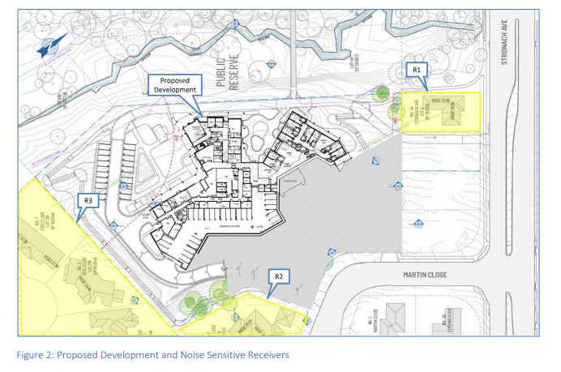

***Figure 5 – Extract from the Acoustic Assessment identifying the development and noise sensitive receivers***

Unattended noise monitoring was conducted between 3rd and 10th April 2020 to capture the ambient noise levels at the site. The site is located approximately 200-300m from the main road noise source Stronach Avenue. In accordance with the *Development near Rail Corridors and Busy Road - Interim Guideline* the development is not expected to be adversely impacted by road traffic noise from the surrounding road network.

*Mechanical Plant Noise*

Figure 6 below identifies that final locations of the rooftop mechanical plant and acoustic screening.

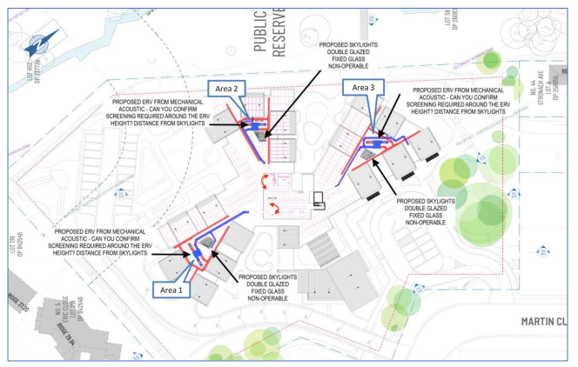

***Figure 6 - Extract from the Acoustic Assessment identifying rooftop mechanical plant***

The predicated plant noise levels from the mechanical plant noise assessment show that compliance with the noise limit of 37 dB(A) Leq is achieved at the closest noise sensitive receivers. No additional noise mitigation measures are required.

*Vehicle Movement Noise*

Figure 7 below identifies that vehicle movement noise sources:

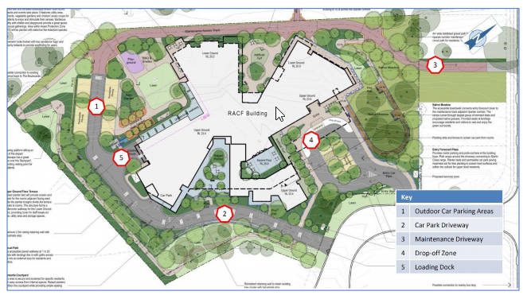

***Figure 7 – Extract from the Acoustic Assessment identifying the vehicle movement noise sources.***

Using a conservative predication method, the result show that the development achieves compliance with the project noise trigger levels at all the identified noise sensitive receivers for the day, evening and night-time assessment periods. The predicated noise impacts also comply with the sleep disturbance criteria. No additional mitigation measures are required.

*Outdoor Community Areas*

The outdoor community areas are expected to be used during the day between 7am and 6pm for exercise and social activities with background music to be played. It is predicted that a maximum number of 50 people may engage in verbal communication simultaneously in the northern outdoor area and 80 people in the southern outdoor area before reaching the daytime noise limits for the nearest residential receivers. The report identifies that it is unlikely that these numbers will be exceeded and therefore expected to adversely impact on the acoustic amenity of the community.

*Construction Noise*

The predicted construction noise impacts exceed the ICNG Noise Management Level of 52 dB(A) during all the construction phases. It is anticipated that a community reaction could be received as a result of the construction noise. The report recommends that temporary noise control measures, such as mobile acoustic barriers, be provide as a temporary relief to high noise impact. A construction noise management plan (CNMP) is required to facilitate community engagement and to set a reliable means of communication. The CNMP will also help identify times when the community is less sensitive to noise, such as, when residents are away for work, and therefore minimise complaints. Council is satisfied that given the construction noise will only occur for a finite period, this can be adequately managed.

The development is considered to be satisfactory in terms of noise and vibration impacts subject to relevant conditions of consent to ensure compliance with the recommendations within the acoustic assessment.

**Privacy**

The development has been designed to with due consideration of visual privacy within the development and neighbouring properties. Given the separation between the arms of the building, the proposed landscaping and angles of the windows the development achieves adequate visual privacy.

To further address concerns raised within the submissions the applicant amended the proposal to introduce privacy blades, balcony screens and window tint finishes where the development interfaces with the adjoining properties (44 Stronach Ave, 3-7 Erin Close and 6 Martin Close) to address any potential privacy issues. Figures 8-13 below demonstrate how the development addresses potential privacy concerns. Council is satisfied that the development is suitable in terms of visual privacy.

44 Stronach Ave – whilst the separation distance is considered generous to this property, at its interface the development also includes the addition of vertical privacy blades, balcony screens and high planting to obscure direct lines of sight.

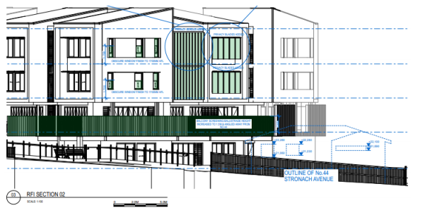

***Figure 8 - Proposed new vertical blade screens and balcony screening where the building interfaces with 44 Stronach Ave***

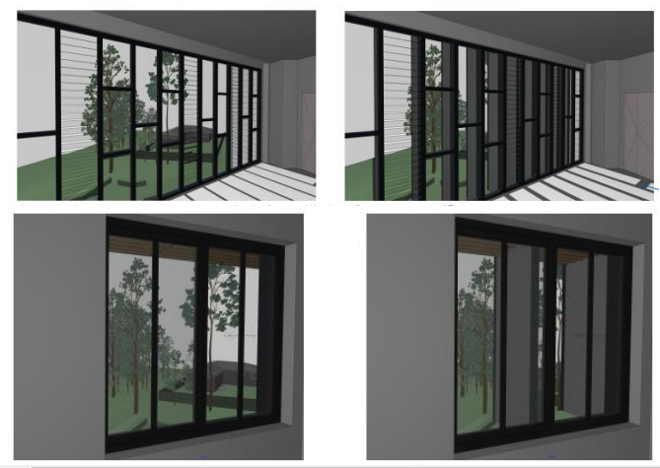

***Figure 9 - Original proposal (left) and amended proposal (right) with vertical privacy blades.***

3-7 Erin Close – The setbacks to these dwelling varies across the site, however ranges from 26.23m – 48.14m. There are also a topographical change in levels where the proposed new loading dock and adjacent internal driveway with a difference of 4.65m from the top of the 1.8m boundary fence.

The applicant has also adopted design features such as window tinting, vertical privacy blades and 1700mm high balcony screening, as well as an additional hedge along the boundary fence to ameliorate visual privacy impacts.

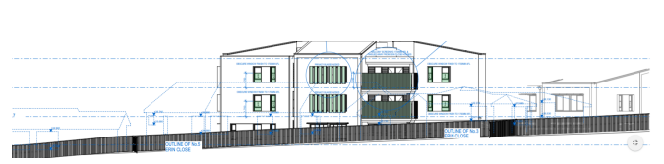

***Figure 10 – Proposed interface with 3 – 7 Erin Close***

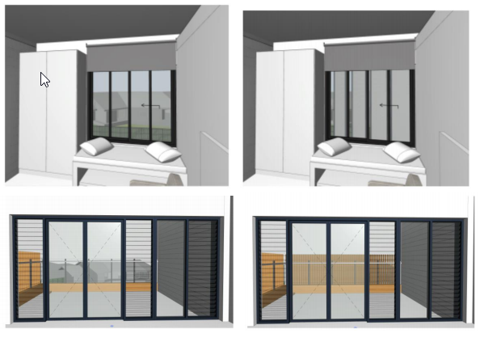

***Figure 11 – Level 2 Original proposal (left) and amended proposal (right) with proposed screening.***

Whist a submissions was not received from any residents on Martin Street, the applicant has further addressed the interface with this existing development.

6 Martin Close – At its closest point the development is setback 24.23m, the applicant has also incorporated window tinting and vertical privacy blades at the interface with Martin Close which will assist with obscuring the outlook away from this property.

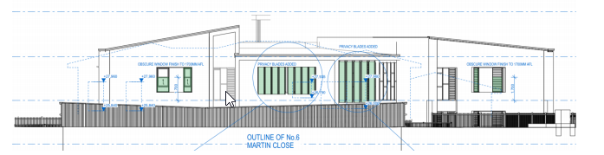

***Figure 12 – Propsed interface with 6 Martin Close***

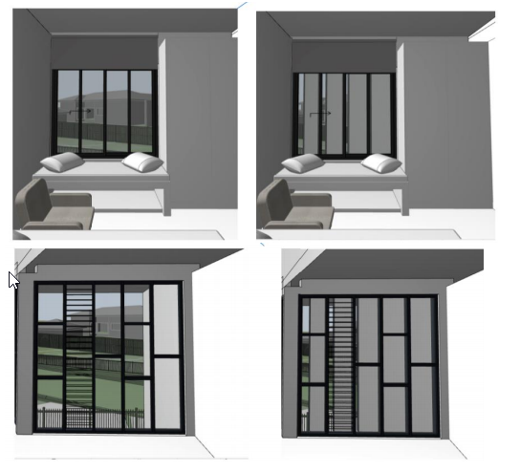

***Figure 13 – Original proposal (left) and amended proposal (right) with proposed screening.***

The proposed development has adequately addressed potential privacy concerns.

**Traffic**

A traffic and parking assessment has been prepared by Ason Group to consider the potential traffic and transport limitations associated with the redevelopment. Traffic generation has been calculated based on RMS Guidelines. Traffic generation will remain moderate and primarily outside of local peak periods. The assessment demonstrates that the trip generation and distribution will essentially mirror the existing RACF operation. Council’s Development Engineer has reviewed the assessment report and SIDRA modelling and determined that the vehicle entry/exit locations are satisfactory and the development is not expected to significantly impact the local road network.

As detailed earlier in the report, the development incorporates car parking in excess of the SEPP and DCP requirements and is considered suitable. The access driveways, aisles, parking spaces and service areas have been designed in accordance with the Australian Standards, with further detail to be provided at Construction Certificate stage. Council is satisfied that the proposal can be supported from a traffic, access and parking perspective.

**Social and Economic Impact**

The proposal will result in a positive social and economic impact. It will provide economic benefits to the local economy during construction and the operational phase.

The application was lodged with a Social Impact Assessment prepared by Ethos Urban. The report identifies that there will be a population growth across the Maitland Local Government Area (LGA), with the projections identifying the proportion of over 60 years old increasing. There is a growing demand for quality RACF’s to cater for this ageing population. The benchmark of 80 residential aged care per 1000 residents aged over 70, means that there is currently an undersupply of 211 places which will increase to 364 by 2021 and 523 by 2026. Whilst there are impacts primarily relating to the construction phase, overall the proposal will create positive social benefit.

**Section 4.15 (1)(c) - The suitability of the site for the development**

The site currently contains an ageing RACF that is intended to be replaced by a contemporary facility. The key physical issues relate to the interface with the surrounding residential development and the riparian corridor, which have been adequately addressed throughout this report. The development will integrate with the existing senior living development to the north and is supported by suitable public transport and commercial development. Accordingly, the site is considered suitable for the proposed development.

**Section 4.15 (1)(d) - Any submissions made in accordance with this Act or the regulations**

***Public Submissions***

The proposal was publicly notified/advertised for a period of thirty (30) days in accordance with the Environmental Planning and Assessment Act 1979 and the Maitland Development Control Plan 2011.

A total of four submissions were received during the exhibition period. A copy can be seen in Attachment E. A summary of the submissions is provided below:

|  |  |
| --- | --- |
| ***Issue*** | ***Comment*** |
| Submission One | |
| No objection to the development, however, would appreciate if Council’s Circular Economy Manager (or equivalent) could support the contractor with identifying appropriate reuse methodologies with their Construction Management Plan that:   * Offset the demolition activities undertake – eg utilise crushed concrete as bedding or recycled glass in the concrete mix etc; * Offset future operational wastage eg utilise recycled materials, plastics in asphalt etc. | Noted. Relevant conditions will be placed on the consent to ensure that the demolition of the existing facility is undertaken with due consideration of re-use and recycling of materials. |
| Submission Two | |
| The loading dock is located adjacent the dwellings on Erin Close, concern that the noise generated from the trucks entering and exiting the site will impact on their dwelling. Request that a barrier be considered to reduce the potential noise impacts. | There are topographical change in levels, where the proposed new loading dock and adjacent internal driveway is located with a level of difference of 4.65m from the top of the adjacent 1.8m boundary fence.  The applicant submitted an acoustic assessment that demonstrates that the development will not create significant acoustic impacts on the surrounding residential development. |
| Some of the bedrooms and porches of the development will be looking straight into the dwellings located in Erin Close impacting on privacy. Would like to know what plans are being considered to counteract this situation. | As detailed earlier in the report the applicant has incorporated additional measures to ensure that the visual privacy of the adjoining dwellings, including along Erin Close have been protected. This includes window tinting, vertical blade, balcony screening and landscaping. |
| Submission Three | |
| The southern arm of the development which rises to a height of 11m includes two bedrooms plus a lounge with a large balcony on levels 1 & 2 which will overlook the neighbouring properties. It is unclear what, if any privacy shields will be used. If none, it is suggested that the following remedies be used to address this issue:   * There be some form of aluminium fins or privacy blades incorporated across these bedroom windows and the balconies so that direct vision into the private yards and homes are eliminated or dramatically reduced; * Planting a row of hedging shrubs to a 3-4m height along the entire length of the southern boundary between the proposed pathway and the three properties on Erin Close. Early planting to achieve the desired height by completion of the development. * Erection of or adding to existing colourbond fence to a height (maximum height permissible) that provides a visual shield blocking vision into the affected yards and providing some noise abatement. | As detailed earlier in the report the applicant has incorporated additional measures to ensure that the visual privacy of the adjoining dwellings, including along Erin Close have been protected. This includes window tinting, vertical blade, balcony screening and landscape screen along the southern boundary.  A 1.8m high colourbond fence will installed along the southern boundary. |
| Concern that the access road, loading dock and carpark which is located adjacent the dwellings on Erin Close will severely impact on the existing amenity. When completed the traffic noise from staff and visitors cars, service, deliveries, waste collection will impact on the quiet enjoyment of our homes. | There are topographical change in levels, where the proposed new loading dock and adjacent internal driveway is located with a level of difference of 4.65m from the top of the adjacent 1.8m boundary fence.  The applicant submitted an acoustic assessment that demonstrates that the development will not create significant acoustic impacts on the surrounding residential development. |
| It is unclear whether access road leading to the rear loading dock and carpark is one way. If not, traffic in both directions may result in unwanted lights impacting on the properties of Erin Close. Also of concern is the potential for road lighting being an issue. | The sealed portion of the access track is to be two way to the enable vehicles to enter and exit the site in a forward direction.  As detailed above the topographical change in levels mean that there won’t be any issue from vehicle headlights. |
| The disturbance to the adjoining dwellings of Erin Close during the construction period will have a negative impact on the existing amenity in relation to noise, dust and possible pollutants being released from the existing buildings. The provision of fence extensions and some form of noise and dust abatement measures will need to be addressed by the developer. | It is acknowledged that there will be impacts on the surrounding residents during the demolition and construction phase of the development.  The acoustic report recommends that temporary noise control measures, such as mobile acoustic barriers, be provide as a temporary relief to high noise impact.  A construction noise management plan (CNMP) is required to facilitate community engagement and to set a reliable means of communication. The CNMP will also help identify times when the community is less sensitive to noise, such as, when residents are away for work, and therefore minimise complaints. Council is satisfied that given the construction noise will only occur for a finite period, this can be adequately managed. |
| Submission Four | |
| The building is too high and permits an occupancy that is too dense which will create impacts to the amenity of privacy to the property at 44 Stronach Ave too severe to allow it to proceed in the current form. There are discrepancies within the documents with regards to whether the development is to be located 30m or 40m from the rear of the adjoining property on Stronach Ave. Either way the development is too high to allow any privacy, with residents, staff, visitors and contractors having direct viewpoint from multiple floors into the backyard of this dwelling, verandah and internal areas of the home. | The plans identify that the proposed building has a setback approximately 29.35m from the rear of 44 Stronach Ave. This is considered to be a generous setback.  The applicant has incorporated additional measures to ensure that the visual privacy of the adjoining dwellings, including Stronach Ave have been protected. This includes window tinting, vertical blade, balcony screening and additional landscaping.    The floor space ratio of the proposed development has been calculated as 0.81:1, the Seniors SEPP identifies that consent cannot be refused for RACF on the grounds of density and scale if the FSR is less than 1:1 or less. The development is therefore not considered to be too dense. |
| The DA is non-compliant with the SEPP (Housing for Seniors and People with a Disability) 2004, specifically Clause 30 in which the site analysis should include information regarding the surrounds of the proposed development, including neighbouring buildings, their height, use, pedestrian and vehicle access, as well as living room windows overlooking the site. It must also specify the location of any facing doors and/or windows. This has not been done for the adjoining dwelling. | The information submitted with the application was considered to be suitable to adequately identify the opportunities and constraints of the site. Nevertheless, the applicant has provided an updated Site Analysis Plan which is provided in Attachment B. |
| The Visual Impact Assessment fails to even mention, in other than a passing gesture, the visual impact of the development in the private domain and specifically to occupants of the dwelling at 44 Stronach Ave. The VIA only assesses the development with regards to the transient pedestrians and road users along Stronach Ave. The VIA emphasises the visual impact on the public domain as opposed to the very tangible, substantial and permanent visual impact posed to the surrounding dwellings in the private domain and suggests that these properties require no detailed consideration.  It isn’t until page 47 of the VIA that a rating of “high” is given to residents at home or people engaged in outdoor recreation when focused on the landscape – not “major” but only “high”. A single line, three words in the table is the embarrassing totality of the reports reasoned consideration of the “private domain” visual impacts of this proposed development. | The VIA generally requires consideration of the private domain where there are attractive landscape features (such as the Opera House etc) that may be impacted. Specific consideration of 44 Stronach Ave was undertaken by the consultants during the scoping phase and it was determined that the visual environment does not warrant consideration of the private domain.  The plans identify that the proposed building has a setback approximately 29.35m from the rear of 44 Stronach Ave. This is considered to be a generous setback.  The applicant has incorporated additional measures to ensure that the visual privacy of the adjoining dwellings, including Stronach Ave have been protected. This includes window tinting, vertical blade, balcony screening and additional landscaping.  It is acknowledged that there will be a change to the outlook from the surrounding properties, however the development has incorporated appropriate measures with the design and landscaping to assist with mitigating these impacts. |
| Raises a concern that the trees which are to be removed as a result of the development are still shown on the superimposed photos within the VIA giving an inaccurate representation of their desired outcome of staying connected with the landscape setting, especially the existing mature trees. | The landscape documentation contains sufficient information to demonstrate that there will be existing vegetation retained as well as additional planting to ensure that the development will fit within its landscape setting. |
| The social impact assessment (SIA) fails to describe any negative impacts (other than to the applicants own residents and staff). The stakeholder groups are all clearly associated with the applicant, which is not compliant with the requirements for a SIA (references the Guideline for State Signficant Mining etc Sept 2017). The SIA is silent on the negative property and social impacts on the adjoining property.  The SIA needs to be amended substantially to expressly acknowledge the negative impacts to the adjoining property rights (e.g., economic livelihood from tenancy of the property, reduction in property value from having an adjacent 15.8 metre building built in close proximity - a building with numerous windows peering into my property’s backyard and living spaces), including the social impacts, perceived and actual, to the occupants of The property, and also the impacts to other neighbouring properties on a similar basis.  The SIA is deficient as it did not engage in actuality with stakeholders outside the applicants own associated communities, and none of the key stakeholders were independent of the applicant.  No impacts arising from the completion of the development are described in relation to the surrounding property owners. The residents referred to in the SIA refer almost exclusively to the residents of the applicant, not the surrounding property owners and residents of the proposed development site.  The SIA mentions the Coronavirus Pandemic as a “long-term” factor, however it makes no comment as to how the size, density and the model of care underlying the development proposal will affect the Applicant’s response to this particular challenge and whether those factors pose real risks to the anticipated 168 residents, numerous staff and visitors to the proposed premises. This is a very serious omission that must be addressed, noting specifically the particular features of the development and how they will impact on an appropriate response to a Pandemic situation. | The SIA considers a range of potential negative impacts for surrounding residents including:   * Increased inconvenience and disruption during construction; * Change to the local community during construction; * Increased traffic during construction.   These impacts will be managed in line with a Construction Management Plan.  The issues raised are addressed throughout the Statement of Environmental Effects and not relevant to the SIA. These issues have been addressed in other section of this assessment.  The application has been advertised and notified for public comment.  As the site currently operates as a RACF, the renewal and redevelopment of the facility is not expected to create any significant negative social impacts.  The SIA identifies that the development will provide contemporary best practice standards in aged care. The long-term impacts of COVID-19 is uncertain and cannot be specifically address in a detailed way.  The SIA is considered sufficient to enable adequate assessment of the proposal. |
| The residential amenity of the adjoining property has not been safeguarded as required by Clause 1.2(j) of the Maitland LEP 2011. The visual character behind their property will be significantly changed, not to mention the change that has already been imposed with the demolition of the adjoining dwellings. The development should be redesigned to reduce the height and reconfigure the windows and lines of sight into the rear of the adjoining properties before consent is given. | This has been addressed throughout the report. |
| The proposal does not comply with Clause 8 – Building Height, Bulk and Scale objectives within the DCP. In addition to the height contraventions, the development significantly breaches what is a reasonable density and scale for what should be contemplated for the general residential zoning of the land. It is clearly too large and incompatible with the residential character of the developments surrounds. | This has been addressed within the DCP portion of this report. The building height, scale and density is considered to be appropriate. |
| The applicant seeks to position the access road, signage and other associated infrastructure directly adjacent the adjoining property when there are other viable alternatives. The access road should wind back to Martin Close the official address and traditional access point into the property. It is noted that no driveway has ever been located on the south-eastern side of 44 Stronach Ave, as the previous dwelling at 42 Stronach Ave had a driveway on the other side. | Council requested that the applicant consider relocating the access track further away from the boundary of 44 Stronach Ave. The development was amended to locate the track 1.5m from the boundary and include landscaping along the boundary. After further discussions the applicant has suggested that they would be supportive of a condition of consent that further moves this to 3m from the boundary. |
| As there are no longer any adjoining dwellings, 44 Stronach Ave sits in isolation. The positioning of the access road and signage gives no consideration to the identification of this property or the residential appearance of the immediate surrounds. | It is noted that the signage has since been removed from development in this location. |
| There are inconsistencies within the application with regards to the intended use of the track with it being referred to as emergency services access track but also a maintenance track allowing vehicles to exit Stronach Ave. What is the actual purpose and how will it be used in practice? | The applicant has confirmed that the design and use of the maintenance track is for emergency vehicles and occasional maintenance purposes only. The access point will be controlled by removable bollard or the like to prevent public access (this will need to comply with the NSW RFS GTA’s).  As noted above the signage on the Stronach Ave frontage is no longer proposed. |
| It is quite likely that, given the current and evolving situation with the Coronavirus Pandemic and its impact on vulnerable elderly populations, and given the current and progressive trend in Aged Care of smaller Aged Care Homes that are integrated into the community - such as the Dutch Humanitas Model, the overall scale and integrated nature of the development as specified in the DA is now arguably not within the Public Interest.  The Commonwealth Government’s Royal Commission into Aged care Quality and Safety commenced on 8 October 2018 and is expected to provide its final report by 12 November 2020. Terms of reference of the Royal Commision include “… how to ensure that aged care services are person-centred” and “… how to best deliver aged care services in a sustainable way through innovative models of care, use of technology, and investment in the aged care workforce and capital infrastructure”. In essence, the future of the aged care sector in Australia is currently being determined.  The DA should not be approved at this time as it cannot be ascertained whether the model of care to be established by the proposed development will be consistent with the Royal Commission’s recommendations and, ultimately, as adopted by the Commonwealth Government.  The proposed development seems to take an outdated standard model of care more like a health facility with a centralised kitchen and designated staff areas etc, in preference to a person-centred approach to care where people are housed in smaller spaces of up to 15-20 people in home-like environments which provides better health outcomes for residents. Smaller and separate facilities of up to 20 people will assist with infection control and containment if required. The above lends serious support that the proposed development is not in the public interest at this particular time.  Council and any consent authority should obtain specialist advice as to whether it is advisable to approve a facility that seeks to house so many people in one interconnected building. Specialist advice should also be obtained on the likely implications of the Royal Commission’s findings. | The development has been designed with distinctive features that promote a household model of care. The households radiate out from the central lift and service core.  A third lift is provided and has the potential to be used as the designated infection control lift to transfer unwell patients.  The design provides for 16 beds per ‘household’ with dedicated dining and lounge areas to prevent overcrowding and allow for social distancing if required.  The applicant has provided illustrative plans showing measures that can be put in place for infection control if required.  It is noted that the future finding of an ongoing Royal Commission into aged care is not a relevant matter for consideration under the EP&A Act and determination of the DA cannot be delayed pending its outcome. |
| A submission from a property valuer has been included as an attachment to the submission which states that the development should not be supported for the following reasons:   * Change in character of the property surrounds; * Disparity of power in acquisition conduct and land of consultation with the adjoining property owner. * Loss of the amenity of privacy * Proposed access road adjacent to the property * Consideration should be given to a change of zoning for the adjoining property to enable both commercial and residential activities | Impact on property valuations and land acquisition conduct is not a relevant matter for consideration under the EP&A Act.  Loss of privacy, the proposed access road location has been adequately addressed in this report.  Again the future zoning of the area is not a relevant matter for consideration, however the submitter is welcome to have discussions with Council’s Strategic Planning Department regarding this matter. |
| Urban design Report (UDR) suggests that the land recently acquired by the applicant on Stronach Ave is likely to be developed after the construction associated with the current DA is completed which is of concern. | 38, 40 & 42 Stronach Ave have a combined area of around 2000sqm which will be capable of future development.  Possible future development is not a matter of consideration for this application. |
| The UDR gives emphasis to the ‘institutional uses’ of land rather than the low density suburban housing. | The RACF is considered to be an institutional use and the report helps the reader to understand its spatial relationship with other institutional uses. |
| The footprint of 44 Stronach Ave is not even featured on the diagrams throughout the report. | The applicant has confirmed this figure was based on an aerial photograph taken before the demolition of 38 – 42 Stronach Ave. It was amended to reflect their absence and 44 Stronach Ave was deleted in error. It is considered that the UDR provides sufficient information to allow assessment of how the development responds to the context of the area. |
| The proposition that the tree canopy on either bank of Two Mile Creek is a justification for the height of a man made structure is absurd. | The information is provided in relation to the existing trees and their relationship with the site. The retention of trees was a key consideration of the design. Their retention assists with maintaining the existing nature of the site, and form part of the visual environment. This however is not considered the reason for support of the proposed development height. |
| The UDR only identifies overshadowing does not occur in mid-winter, it can only be assumed that overshadowing will occur at other times of the year. | Overshadowing is most acute in mid-winter and shadows are shorter at all other times of the year. Council is satisfied that the proposed development will not impact on solar access for the surrounding development. |
| The UDR identifies a walking track surrounding 44 Stronach Ave, with a possible future walking track along the northern side which is objected to. | It appears from the site inspection that there is informal use of the northern side of 44 Stronach Ave as a walking track to access the footpath on Stronach Ave heading towards Greenhills Shopping Centre. The construction of a formed access track will most likely be utilised in the future. The possible future walking track does not form part of this application. |
| Bushfire Assessment Report identifies that the Plan of Management for Two Mile Creek allows for the development to be located closer to the riparian corridor than would have otherwise been possible.  There is no information confirming that the Bushfire Management conforms with Planning for Bushfire Protection. | The application is supported by a Bushfire Threat Assessment which was referred to the NSW RFS for approval under 100b of the Rural Fires Act. The NSW RFS have assessed the proposal and issued General Terms of Approval which will need to be complied with . |

***Internal Referrals***

Development Engineer – The application has been assessed by Council’s Development Engineer. The development can be supported from an engineering perspective subject to conditions of consent.

Environmental Health Officer – The application has been assessed by Council’s EHO in relation to compliance with the relevant Australian Standards. The application was submitted with a Kitchen Operational brief which includes details of the fit out. Full details will be required with the Construction Certificate. The development can be supported from an environmental health perspective subject to conditions of consent.

Assets Engineer – Given the proposal includes future maintenance of the Riparian Corridor, Council’s Principle Assets Engineer reviewed the Bushfire Fuel Management Plan Proposal. Council has agreed in principle to this future maintenance, however a formal agreement and sign off on the Plan of Management will need to occur prior to the issue of Occupation Certificate.

Building – The application has been assessed by Council’s Team Leader Building Assessment. The proposal can be supported from a building compliance perspective subject to conditions. It is noted that a few minor amendments are required to ensure compliance with the relevant requirements, however this can be addressed at Construction Certificate stage.

Traffic – The application has been assessed by Council’s Infrastructure Planning Engineer. The proposal is considered suitable in relation to transport related infrastructure, and can be supported subject to conditions.

**Section 4.15(1)(e) - The public interest**

The proposal satisfies the provisions of the Maitland LEP 2011 and will provide for additional residential aged care beds in a suitable location. The proposal is considered to be in the broader public interest.

**Development Contributions**

The proposed development would generally attract development contributions under the Maitland Section 94A Levy Development Contributions Plan 2013. In accordance with the Ministers 94E directions Crown development or development by not for profit organisations where they are carried out with the underlying philosophy of community service will not be levied contributions under Section 94A.

Fresh Hope Care are a not for profit organisation and are exempted from contributions on the basis that they are a social housing provider.

**Conclusion**

An assessment of the application has been undertaken against Section 4.15(1) of the *EP&A Act as amended*. The proposed development is considered acceptable in terms of the relevant matters for consideration under the Act and the development application is recommended for approval subject to the imposition of consent conditions.